1. 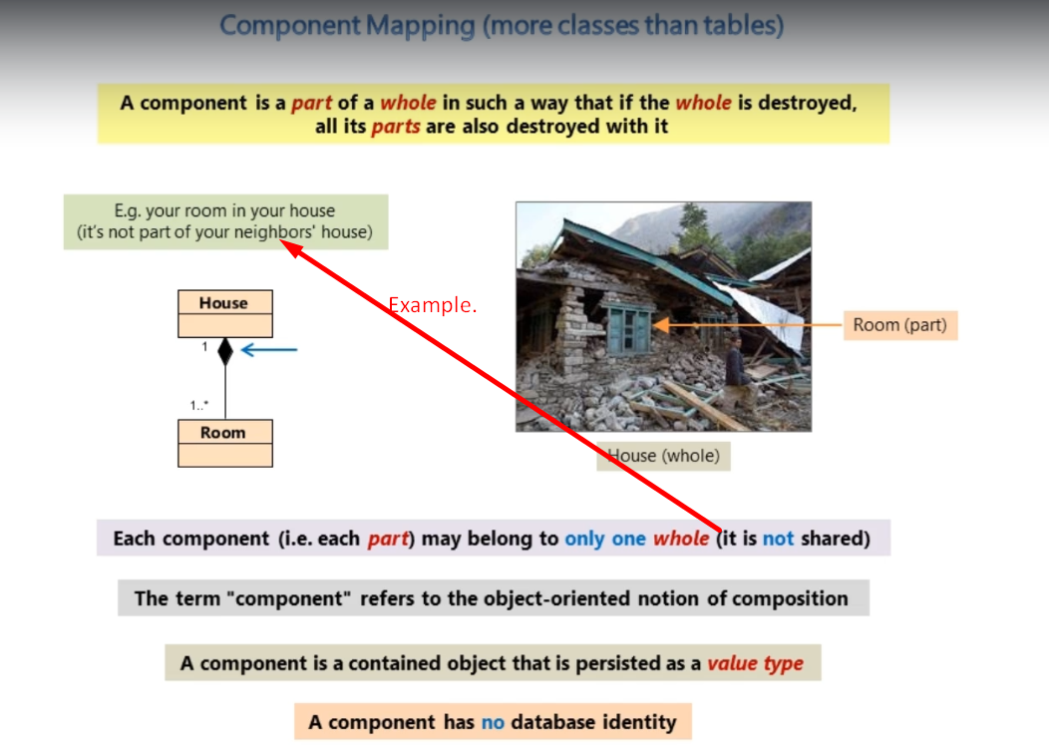
2. 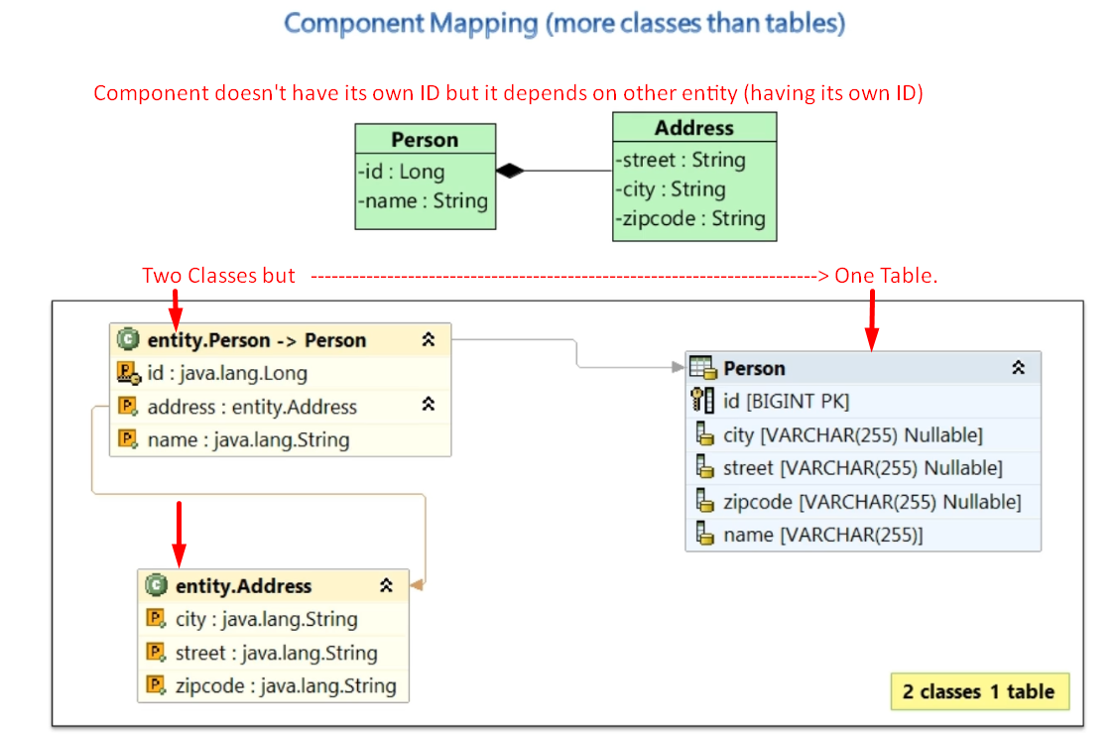
3. The address component is contained by Person Entity.  
   The address component will be persisted as a value inside the Person Table when persisting Person entity.  
   Component can’t be referenced by any other entity rather than the entity which contains that component.  
   See the following Diagram.
4. 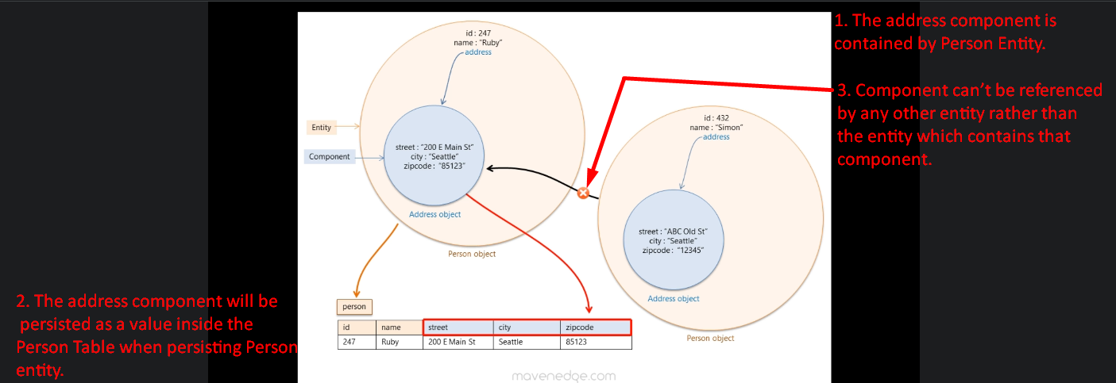
5. @**Entity**: To make a class Persistence Entity Class.  
   @**Embeddable**: To make a class Persistence Component Class.  
   It doesn’t have any identifying attribute as a component has no individual identity.  
   @Embedded: To mark a class component of Entity Class we annotate property with @Embedded  
   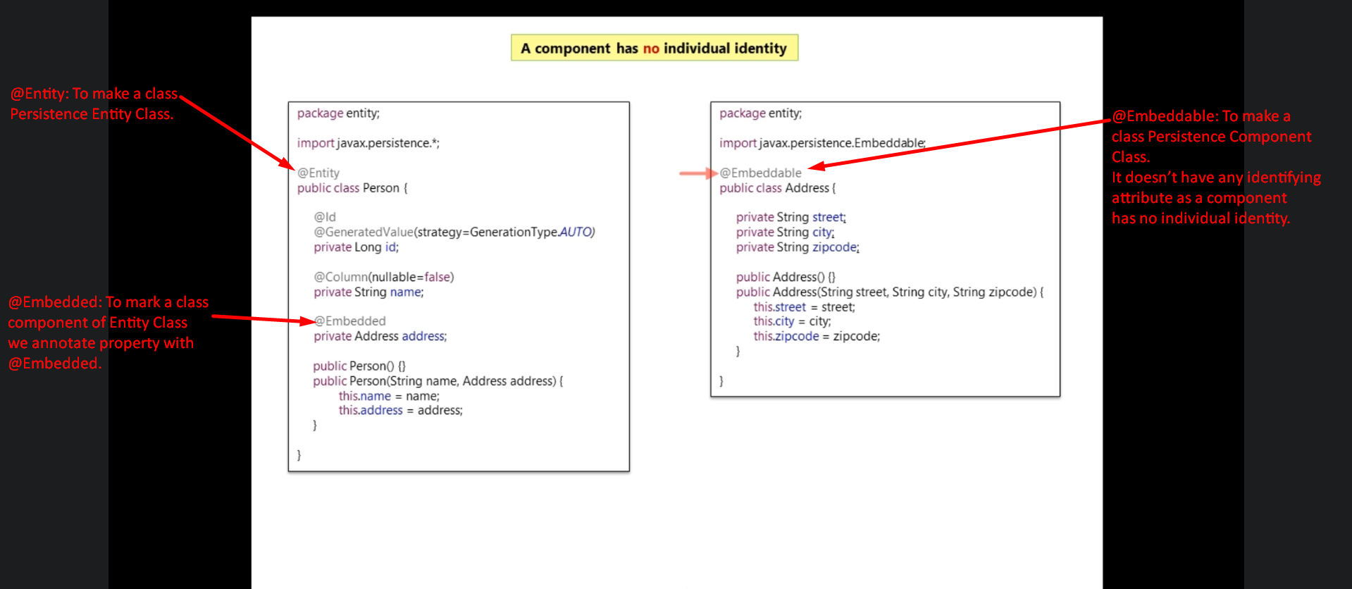
6. 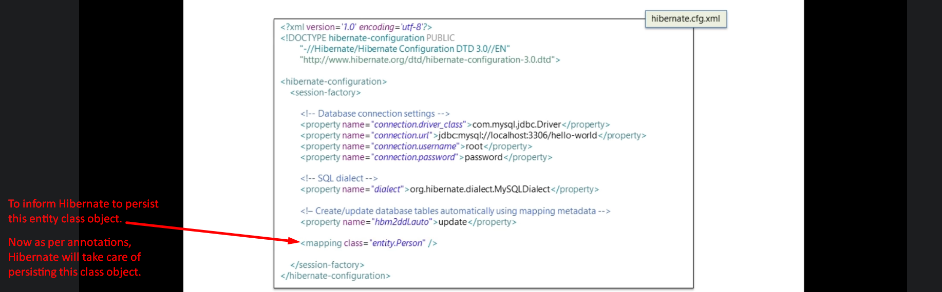
7. 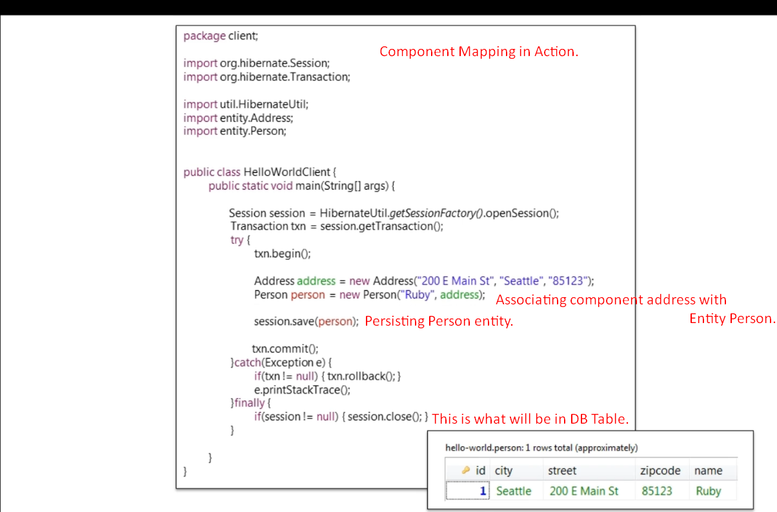
8. 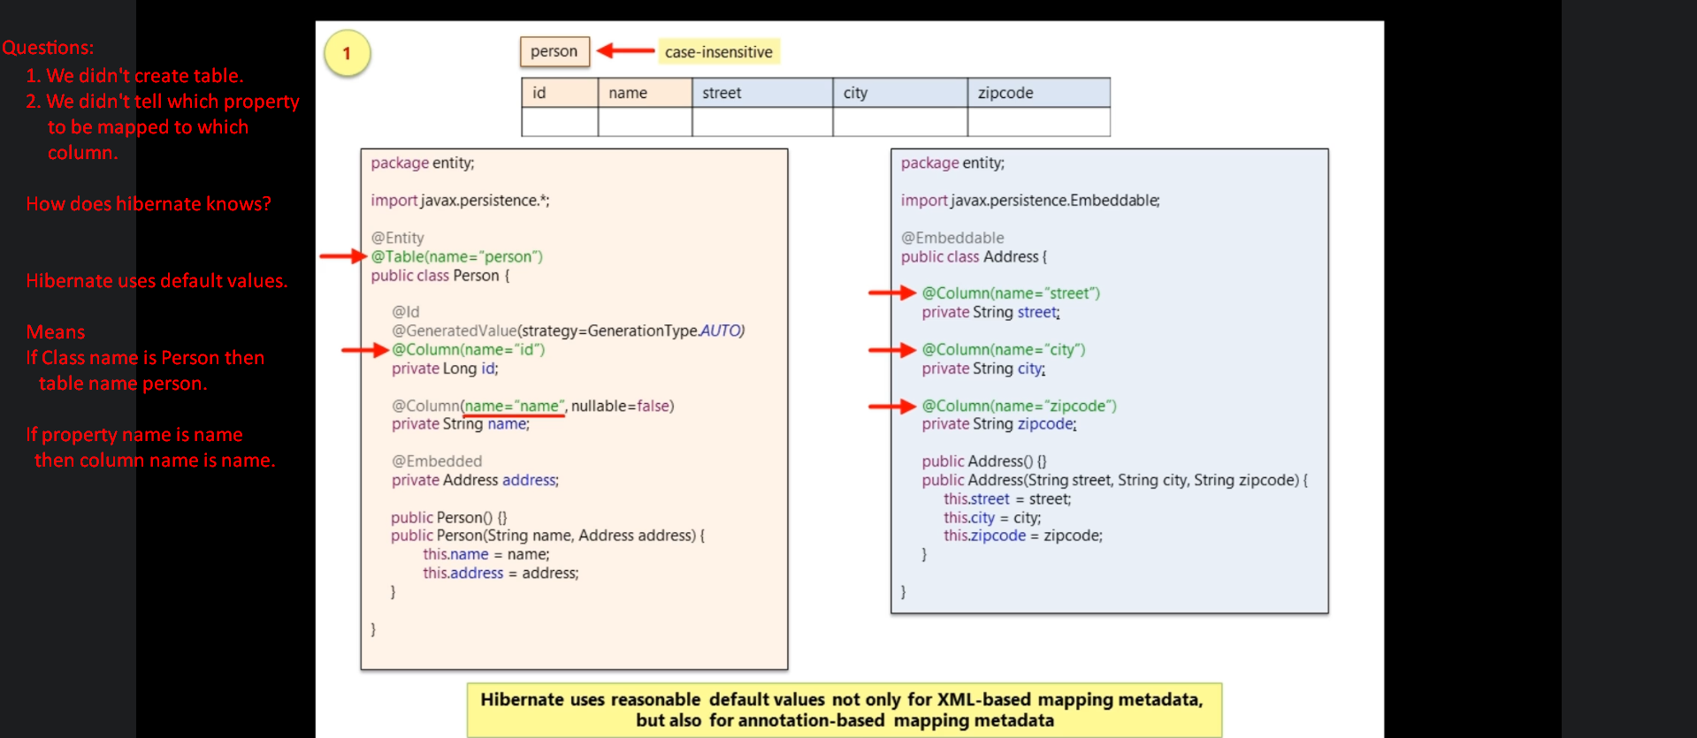
9. 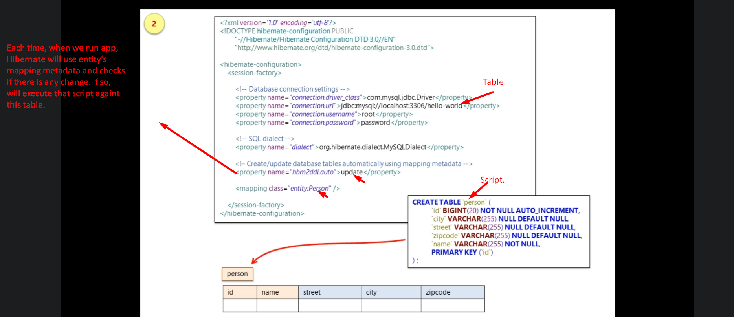  
   Good tool for Development Environment.
10. 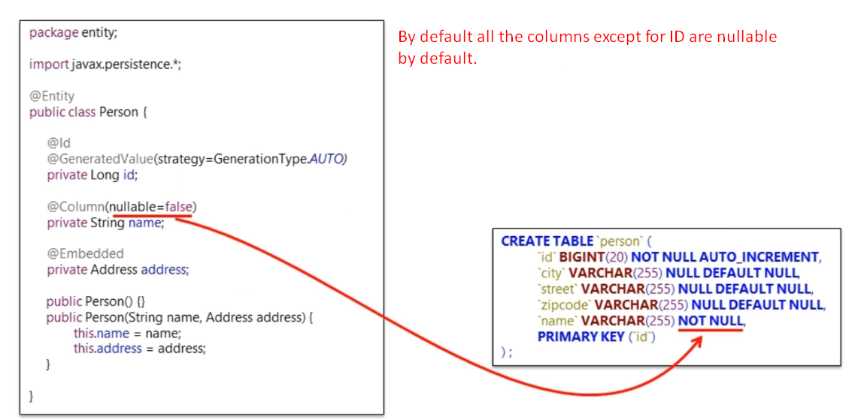
11. How to customize the attribute/property mappings in the component class (Address)
12. 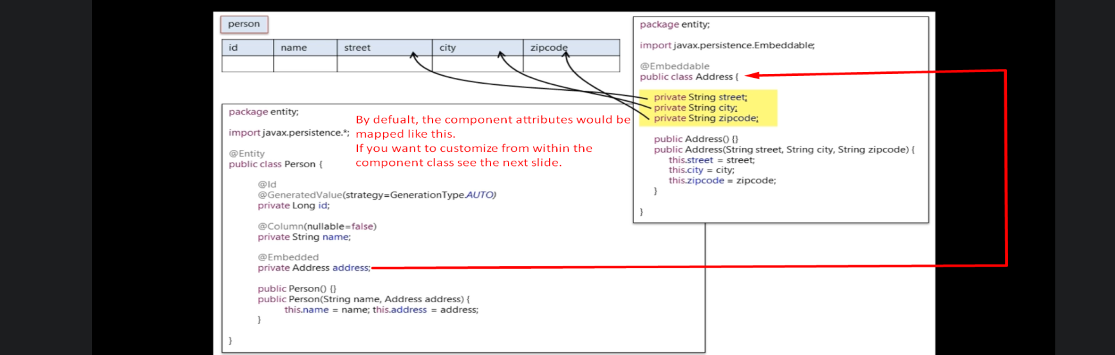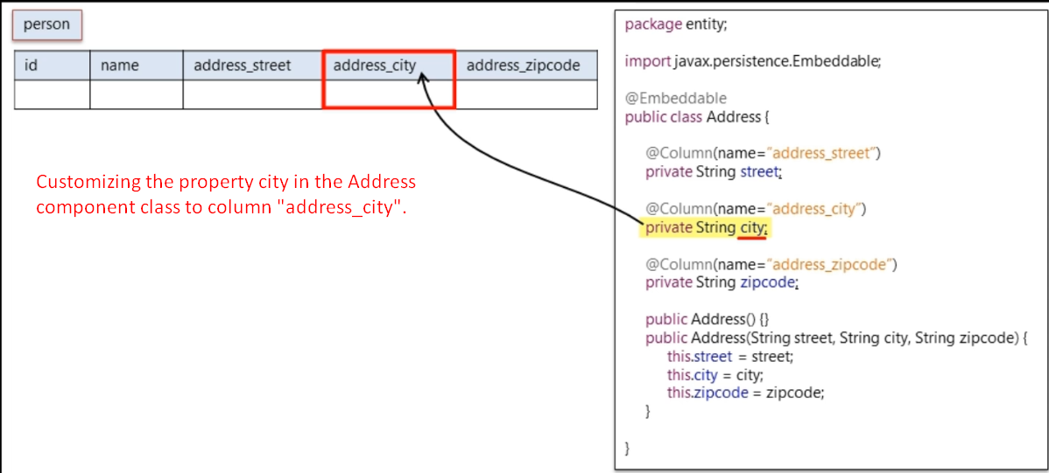
13. This customization is made inside the component class itself but what if you want to customize not inside the component class itself but inside the entity class which contains the component.
14. 